# Effect of Severe Weather on Population Health and Economy

## Synopsis

Severe weather can have very devastating effects on the stricken areas. It can cause loss of life in addition to shattering economic damage. This report analyzes the data of natural disasters from the U.S. National Oceanic and Atmospheric Administration's (NOAA) database that spans the time between 1950 and 2011.

## Data Processing

1. Set the directory to where the Code folder of this project resides:

*setwd("C:/Users/Aiman/Box Sync/NSU/DataScience/5.Reproducible Research/Week3/Code/")*

1. Extract the data from the downloaded file either programmatically or using an unzipping tool.
2. Read the data:

*stormData <- read.csv("C:/Users/Aiman/Box Sync/NSU/DataScience/5.Reproducible Research/Week3/Data/repdata_data_StormData.csv", sep = ",")*

1. Fourth get the structure of the data:

*str(stormData)*

'data.frame': 902297 obs. of 37 variables:

$ STATE__ : num 1 1 1 1 1 1 1 1 1 1 ...

$ BGN_DATE : Factor w/ 16335 levels "1/1/1966 0:00:00",..: 6523 6523 4242 11116 2224 2224 2260 383 3980 3980 ...

$ BGN_TIME : Factor w/ 3608 levels "00:00:00 AM",..: 272 287 2705 1683 2584 3186 242 1683 3186 3186 ...

$ TIME_ZONE : Factor w/ 22 levels "ADT","AKS","AST",..: 7 7 7 7 7 7 7 7 7 7 ...

$ COUNTY : num 97 3 57 89 43 77 9 123 125 57 ...

$ COUNTYNAME: Factor w/ 29601 levels "","5NM E OF MACKINAC BRIDGE TO PRESQUE ISLE LT MI",..: 13513 1873 4598 10592 4372 10094 1973 23873 24418 4598 ...

$ STATE : Factor w/ 72 levels "AK","AL","AM",..: 2 2 2 2 2 2 2 2 2 2 ...

$ EVTYPE : Factor w/ 985 levels " HIGH SURF ADVISORY",..: 834 834 834 834 834 834 834 834 834 834 ...

$ BGN_RANGE : num 0 0 0 0 0 0 0 0 0 0 ...

$ BGN_AZI : Factor w/ 35 levels ""," N"," NW",..: 1 1 1 1 1 1 1 1 1 1 ...

$ BGN_LOCATI: Factor w/ 54429 levels "","- 1 N Albion",..: 1 1 1 1 1 1 1 1 1 1 ...

$ END_DATE : Factor w/ 6663 levels "","1/1/1993 0:00:00",..: 1 1 1 1 1 1 1 1 1 1 ...

$ END_TIME : Factor w/ 3647 levels ""," 0900CST",..: 1 1 1 1 1 1 1 1 1 1 ...

$ COUNTY_END: num 0 0 0 0 0 0 0 0 0 0 ...

$ COUNTYENDN: logi NA NA NA NA NA NA ...

$ END_RANGE : num 0 0 0 0 0 0 0 0 0 0 ...

$ END_AZI : Factor w/ 24 levels "","E","ENE","ESE",..: 1 1 1 1 1 1 1 1 1 1 ...

$ END_LOCATI: Factor w/ 34506 levels "","- .5 NNW",..: 1 1 1 1 1 1 1 1 1 1 ...

$ LENGTH : num 14 2 0.1 0 0 1.5 1.5 0 3.3 2.3 ...

$ WIDTH : num 100 150 123 100 150 177 33 33 100 100 ...

$ F : int 3 2 2 2 2 2 2 1 3 3 ...

$ MAG : num 0 0 0 0 0 0 0 0 0 0 ...

$ FATALITIES: num 0 0 0 0 0 0 0 0 1 0 ...

$ INJURIES : num 15 0 2 2 2 6 1 0 14 0 ...

$ PROPDMG : num 25 2.5 25 2.5 2.5 2.5 2.5 2.5 25 25 ...

$ PROPDMGEXP: Factor w/ 19 levels "","-","?","+",..: 17 17 17 17 17 17 17 17 17 17 ...

$ CROPDMG : num 0 0 0 0 0 0 0 0 0 0 ...

$ CROPDMGEXP: Factor w/ 9 levels "","?","0","2",..: 1 1 1 1 1 1 1 1 1 1 ...

$ WFO : Factor w/ 542 levels ""," CI","$AC",..: 1 1 1 1 1 1 1 1 1 1 ...

$ STATEOFFIC: Factor w/ 250 levels "","ALABAMA, Central",..: 1 1 1 1 1 1 1 1 1 1 ...

$ ZONENAMES : Factor w/ 25112 levels ""," "| __truncated__,..: 1 1 1 1 1 1 1 1 1 1 ...

$ LATITUDE : num 3040 3042 3340 3458 3412 ...

$ LONGITUDE : num 8812 8755 8742 8626 8642 ...

$ LATITUDE_E: num 3051 0 0 0 0 ...

$ LONGITUDE_: num 8806 0 0 0 0 ...

$ REMARKS : Factor w/ 436774 levels "","-2 at Deer Park\n",..: 1 1 1 1 1 1 1 1 1 1 ...

$ REFNUM : num 1 2 3 4 5 6 7 8 9 10 ...

1. Take a subset of the data:

*subStorm <- stormData [,c("STATE", "EVTYPE", "FATALITIES", "INJURIES", "PROPDMG", "PROPDMGEXP","CROPDMG", "CROPDMGEXP")]*

## Results

We will analyze the deaths, injuries, and economic losses per event from 1950 to November 2011.

### Deaths

deathData <- aggregate (FATALITIES~EVTYPE, subStorm, sum)

deathData <- deathData [order(deathData$FATALITIES, decreasing=TRUE),]

png(filename = "../Plots/Deaths.png")

barplot (height = deathData$FATALITIES[1:30], names.arg = deathData$EVTYPE[1:30], las = 2, cex.names= 0.8,

col = rainbow (30, start=0, end=0.5))

title (main = "Deaths Per Event", line=-5)

title (ylab = "Total Number of Deaths", line=4)

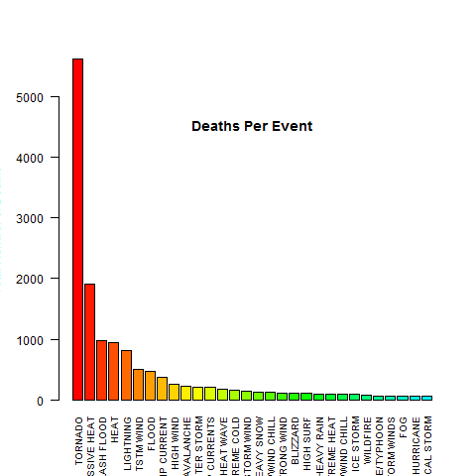

### Injuries

injurData <- aggregate (INJURIES~EVTYPE, stormData, sum)

injurData <- injurData [order(injurData$INJURIES, decreasing=TRUE),]

par(mar=c(12, 6, 1, 1))

png(filename = "../Plots/Injuries.png")

barplot (height = injurData$INJURIES[1:30], names.arg = injurData$EVTYPE[1:30], las = 2, cex.names = 0.8,

col = rainbow (30, start=0, end=0.5))

title (main = "Injuries Per Event", line=-5)

title (ylab = "Total number of Injuries", line=4)

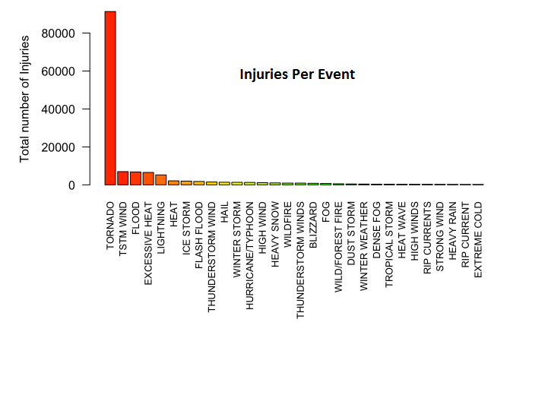

#### Damage

symbol <- c("", "+", "-", "?", 0:9, "h", "H", "k", "K", "m", "M", "b", "B");

factor <- c(rep(0,4), 0:9, 2, 2, 3, 3, 6, 6, 9, 9)

multiplier <- data.frame (symbol, factor)

subStorm$damage.prop <- subStorm$PROPDMG*10^multiplier[match(subStorm$PROPDMGEXP,multiplier$symbol),2]

subStorm$damage.crop <- subStorm$CROPDMG*10^multiplier[match(subStorm$CROPDMGEXP,multiplier$symbol),2]

subStorm$damage <- subStorm$damage.prop + subStorm$damage.crop

damage <- aggregate (damage~EVTYPE, subStorm, sum);

damage$bilion <- damage$damage / 1e9;

damage <- damage [order(damage$bilion, decreasing=TRUE),]

png(filename = "../Plots/Damages.png")

barplot (height = damage$bilion[1:30], names.arg = damage$EVTYPE[1:30], las = 2, cex.names = 0.8,

col = rainbow (30, start=0, end=0.5))

title ("Damages Per Event", line=-5)

title (ylab = "Total Damage In Bilion of US$")

